From your account homepage click the Skaters icon and then click your skater’s name.
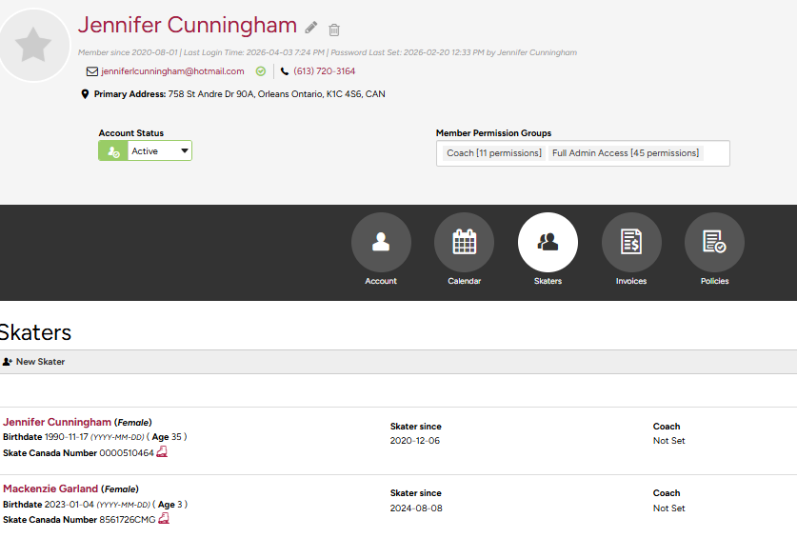
From your skater’s profile page click Assessments and then click on the drop-down menu to view all published assessments.
